Schedule Manager Registration

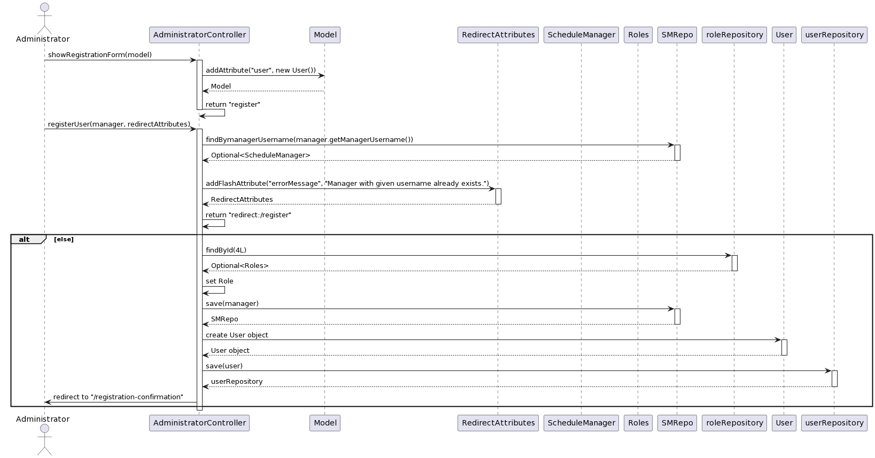

@startuml

actor Administrator

participant AdministratorController

participant Model

participant RedirectAttributes

participant ScheduleManager

participant Roles

participant SMRepo

participant roleRepository

participant User

participant userRepository

Administrator -> AdministratorController: showRegistrationForm(model)

activate AdministratorController

AdministratorController -> Model: addAttribute("user", new User())

Model --> AdministratorController: Model

AdministratorController -> AdministratorController: return "register"

deactivate AdministratorController

Administrator -> AdministratorController: registerUser(manager, redirectAttributes)

activate AdministratorController

AdministratorController -> SMRepo: findBymanagerUsername(manager.getManagerUsername())

activate SMRepo

SMRepo --> AdministratorController: Optional<ScheduleManager>

deactivate SMRepo

alt If Manager with Given Username Exists

AdministratorController -> RedirectAttributes: addFlashAttribute("errorMessage", "Manager with given username already exists.")

activate RedirectAttributes

RedirectAttributes --> AdministratorController: RedirectAttributes

deactivate RedirectAttributes

AdministratorController -> AdministratorController: return "redirect:/register"

alt else

AdministratorController -> roleRepository: findById(4L)

activate roleRepository

roleRepository --> AdministratorController: Optional<Roles>

deactivate roleRepository

AdministratorController -> AdministratorController: set Role

AdministratorController -> SMRepo: save(manager)

activate SMRepo

SMRepo --> AdministratorController: SMRepo

deactivate SMRepo

AdministratorController -> User: create User object

activate User

User --> AdministratorController: User object

deactivate User

AdministratorController -> userRepository: save(user)

activate userRepository

userRepository --> AdministratorController: userRepository

deactivate userRepository

AdministratorController -> Administrator: redirect to "/registration-confirmation"

end

deactivate AdministratorController

@enduml